Abubakkar Abdullah
20P-0045
Lab-Task-2
Section BCS-6C
------------------

Question 1:
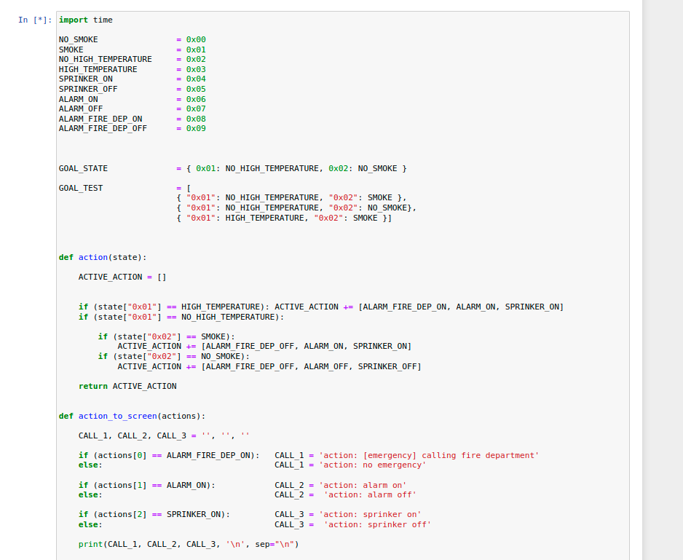
.
System contains the,
- Alarm
- Temperature Detector
- Smoke Detector
- Sprinkling System
- Calling The FireDept

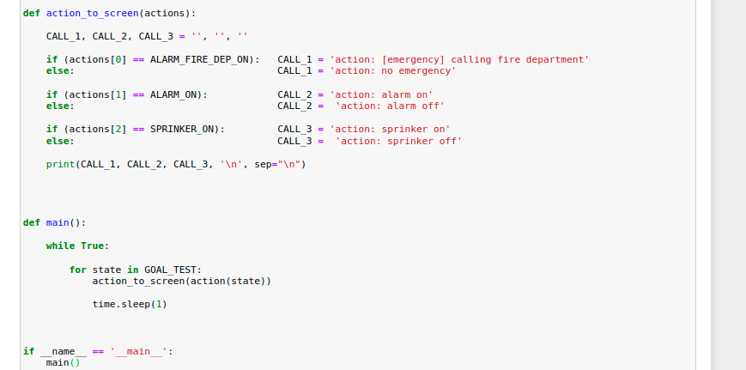
.
.
Action appending on the screen.

Main:
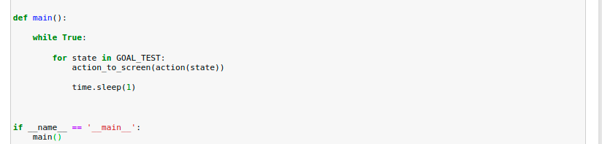
.
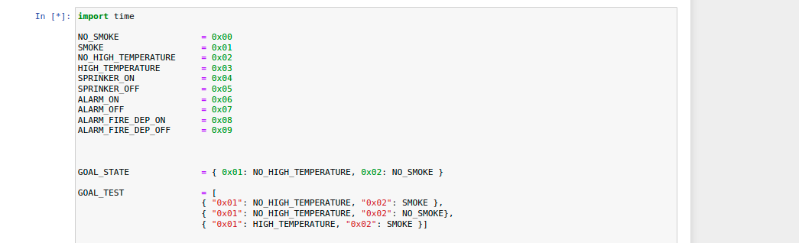
Working:
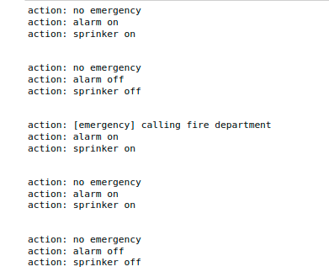
.
.
.
.
.

.
Question 2:
.
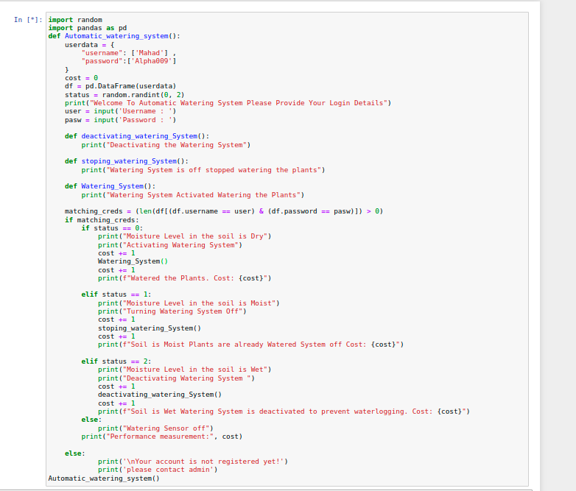
.
.
END

